Section I: Scenario Demographics

Scenario Title: | Pericardial tamponade and the referral-consultant interaction
Date of Development: | 6/4/2018
Target Learning Group: | Juniors (PGY 1 – 2) Seniors (PGY ≥ 3) All Groups

Section II: Scenario Developers

Scenario Developer(s): | Dr. Jared Baylis
Affiliations/Institution(s): | UBC
Contact E-mail (optional): | jbaylis@alumni.ubc.ca

Section III: Curriculum Integration

Learning Goals & Objectives
Educational Goal: | - Use a standardized approach to effectively communicate and elicit a consultant’s involvement in urgent treatment of pericardial effusion with tamponade physiology (e.g. CONSULT, PIQUED, 5C)
CRM Objectives: | - Demonstrate effective closed-loop communication and delegate roles to team members
Medical Objectives: | - Recognize Beck’s triad of clinical tamponade (hypotension, diminished heart sounds, and jugular venous distension)  - Apply an appropriate workup to the patient with dyspnea and hypotension keeping in mind the broad differential diagnosis

Case Summary: Brief Summary of Case Progression and Major Events
In this case, learners will be expected to recognize that this 58-year-old female patient with metastatic non-small-cell lung cancer has tamponade physiology secondary to a malignant pericardial effusion. The patient will stabilize somewhat with a gentle fluid bolus but the learners will be expected to urgently consult cardiology or cardiac/thoracic surgery (depending on the centre) for a pericardiocentesis and/or pericardial window.

References
Marx J, Walls R, Hockberger R. Rosen's Emergency Medicine-Concepts and Clinical Practice E-Book. Elsevier Health Sciences; 2013 Aug 1.
Kessler CS, Afshar Y, Sardar G, Yudkowsky R, Ankel F, Schwartz A. A prospective, randomized, controlled study demonstrating a novel, effective model of transfer of care between physicians: the 5 Cs of consultation. Academic Emergency Medicine. 2012 Aug 1;19(8):968-74. DOI: 10.1111/j.1553-2712.2012.01412.x
Podolsky A, Stern DT, Peccoralo L. The courteous consult: a CONSULT card and training to improve resident consults. Journal of graduate medical education. 2015 Mar;7(1):113-7. DOI: 10.4300/JGME-D-14-00207.1
Chan T, Orlich D, Kulasegaram K, Sherbino J. Understanding communication between emergency and consulting physicians: a qualitative study that describes and defines the essential elements of the emergency department consultation-referral process for the junior learner. Canadian Journal of Emergency Medicine. 2013 Jan;15(1):42-51.
PMID:23283122

Section IV: Scenario Script

A. Clinical Vignette: To Read Aloud at Beginning of Case
You are a junior resident working in a tertiary care centre emergency department and you are asked to see a 58-year-old female patient who was sent in from the cancer centre. She is known to have metastatic non-small-cell lung cancer and has been increasingly dyspneic with postural pre-syncope over the last few days. Her history is significant for a previous malignant pericardial effusion that was drained therapeutically a few months ago.
B. Scenario Cast & Realism
Patient: | Computerized Mannequin |  |  |  |  | Realism:  Select most important dimension(s) |  |  | Conceptual
 | Mannequin |  |  |  |  |  |  |  | Physical
 | Standardized Patient |  |  |  |  |  |  |  | Emotional/Experiential
 | Hybrid |  |  |  |  |  |  |  | Other:
 | Task Trainer |  |  |  |  |  |  |  | N/A
Confederates | Brief Description of Role
Consultant Physician | Answer the phone call when the team consults cardiology, cardiac surgery, and/or thoracic surgery. Listen to the story and then request any extra relevant information that was not provided in the consult request as per the chosen standardized consultation request format (e.g. 5C, PIQUED, CONSULT, etc).
Nurse (or someone playing that role) | If the team asks for a pericardiocentesis kit to perform a bedside procedure, mention that you are not comfortable with proceeding (“the patient seems to have stabilized, don’t we have time to have this patient taken for her procedure in the cath lab or OR?”). Also, report that you found jugular venous distension and muffled heart sounds on exam.
C. Required Monitors
EKG Leads/Wires |  |  | Temperature Probe |  |  |  | Central Venous Line
NIBP Cuff |  |  | Defibrillator Pads |  |  |  | Capnography
Pulse Oximeter |  |  | Arterial Line |  |  |  | Other:
D. Required Equipment
Gloves |  |  | Nasal Prongs |  |  |  | Scalpel
Stethoscope |  |  | Venturi Mask |  |  |  | Tube Thoracostomy Kit
Defibrillator |  |  | Non-Rebreather Mask |  |  |  | Cricothyroidotomy Kit
IV Bags/Lines |  |  | Bag Valve Mask |  |  |  | Thoracotomy Kit
IV Push Medications |  |  | Laryngoscope |  |  |  | Central Line Kit
PO Tabs |  |  | Video Assisted Laryngoscope |  |  |  | Arterial Line Kit
Blood Products |  |  | ET Tubes |  |  |  | Other:
Intraosseous Set-up |  |  | LMA |  |  |  | Other:
E. Moulage
No specific moulage

F. Approximate Timing
Set-Up: |  | 10 min |  | Scenario: | 10 min |  |  | Debriefing: |  | 25 min
Section V: Patient Data and Baseline State

A. Patient Profile and History
Patient Name: Lisa Smith |  |  |  |  |  | Age: 58 |  |  |  |  |  |  |  | Weight: 70kg
Gender: M F |  |  |  |  |  | Code Status: No CPR or intubation but will accept life prolonging procedures other than these.
Chief Complaint: Dyspnea
History of Presenting Illness: 2-3 days of increasing shortness of breath on exertion with associated postural presyncope. No chest pain. No calf pain or history of DVT. No cough, fever, chills, or sweats. Not on active chemotherapy currently. No hemoptysis.
Past Medical History: |  | Hypothyroidism |  |  |  |  | Medications: |  |  |  |  | Amlodipine 10mg PO daily
 |  | Hypertension |  |  |  |  |  |  |  |  |  | Levothyroxine 75mcg PO daily
 |  | Metastatic lung cancer
Allergies: None
Social History: Lives with husband. 40 pack year history of smoking.
Family History: Non-contributory.
Review of Systems: |  | CNS: |  |  | No headache, vertigo, weakness, paresthesias.
 |  | HEENT: |  |  | No vision changes.
 |  | CVS: |  |  | No palpitations or chest pain. Mild postural presyncope.
 |  | RESP: |  |  | Dyspnea, no cough, sputum, or hemoptysis.
 |  | GI: |  |  | No nausea, vomiting, diarrhea, constipation, melena, or hematochezia.
 |  | GU: |  |  | No dysuria, urgency, frequency, or hematuria. Menopause.
 |  | MSK: |  |  | No pain or swelling. |  |  |  |  |  |  |  | INT:
B. Baseline Simulator State and Physical Exam
No Monitor Display |  |  |  | Monitor On, no data displayed |  |  |  |  |  |  | Monitor on Standard Display
HR: 108/min |  |  | BP: 88/52 |  |  |  |  | RR: 28/min |  |  |  |  |  |  | O₂SAT: 97%
Rhythm: Sinus Tachycardia |  |  | T: 36.4ºC |  |  |  |  | Glucose: 5.2mmol/L |  |  |  |  |  |  | GCS: 15 (E4 V5 M6)
General Status: Looks well, mild dyspnea, no presyncope when lying calmly in bed.
CNS: | GCS 15
HEENT: | Jugular venous distension
CVS: | Muffled heart sounds
RESP: | Good air entry to bases, no crackles, no wheezing
ABDO: | Soft, non-tender
GU: | N/A
MSK: | No signs of DVT, normal |  |  |  |  |  |  |  | SKIN: | Normal

Scenario States, Modifiers and Triggers
Patient State | Patient Status | Learner Actions, Modifiers & Triggers to Move to Next State
1. Baseline State  Rhythm: SR  HR: 108/min  BP: 88/52  RR: 28/min  O₂SAT: 97%  T: 36.4ºC | Hypotensive | Learner Actions  - Initiate IV access, monitors, labs, ECG, pCXR  - Perform an initial history and physical exam being careful to gain all relevant details  - Communicate with the patient who is completely awake  - Administer cautious fluid bolus (500mL RL or NS IV) | Modifiers  Changes to patient condition based on learner action  - Crystalloid bolus HR 106 and BP 100/54  Triggers  For progression to next state  - All actions completed or 5 minutes elapsed 2. Diagnosis
2. Diagnosis  Rhythm: SR  HR: 108/min  BP: 100/54  RR: 28/min  O₂SAT: 97%  T: 36.4ºC | Apprehensive about procedure | Learner Actions  - Interpret ECG and pCXR  - Perform POCUS and recognize pericardial effusion  - Vocalize working diagnosis  - Call ICU, cardiology and/or cardiac/thoracic surgery consultations | Modifiers  - RN to prompt consultation if asked for pericardiocentesis kit  Triggers  - All actions completed or 5 minutes elapsed  3. Consultation
3. Consultation  Rhythm: SR  HR: 106/min  BP: 100/54  RR: 28/min  O₂SAT: 97%  T: 36.4ºC | Stable | Learner Actions  - Introduce self and rank to consultant  - Give “one-liner” summary of patient  - Ask core clinical question  - Collaborate with consultant on care plan including re-iteration of timing of consultation  - Close the loop and summarize the plan  **These actions may vary depending on which consultation model you use (5C, PIQUED, CONSULT, etc) | Modifiers  Triggers  - End of case after consultation
Section VI: Scenario Progression

Section VII: Supporting Documents, Laboratory Results, & Multimedia

Laboratory Results
N/A

Images (ECGs, CXRs, etc.)
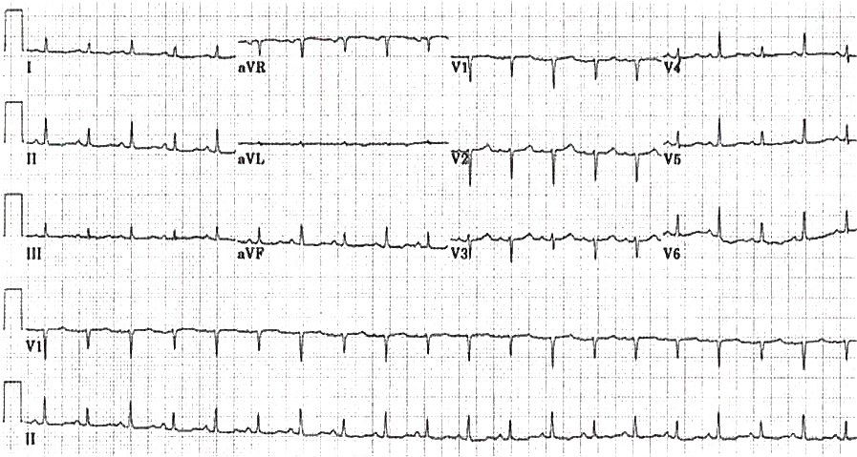  Reference:  https://lifeinthefastlane.com/ecg-library/basics/low-qrs-voltage/  ECG showing sinus tachycardia with low voltage. | Case courtesy of A.Prof Frank Gaillard https://radiopaedia.org  CXR showing cardiomegaly.
Ultrasound Video Files (if applicable)
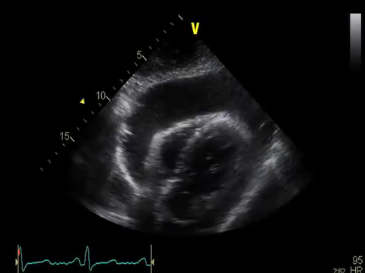
Reference: https://www.youtube.com/watch?v=qAlU8qhC1cU

POCUS with pericardial effusion

Section VIII: Debriefing Guide

General Debriefing Plan
Individual | Group |  | With Video | Without Video
Objectives
Educational Goal: |  | - Use a standardized approach to effectively communicate and elicit a consultant’s involvement in urgent treatment of pericardial effusion with tamponade physiology (e.g. CONSULT, PIQUED, 5C)
CRM Objectives: |  | - Demonstrate effective closed-loop communication and delegate roles to team members
Medical Objectives: |  | - Recognize Beck’s triad of clinical tamponade (hypotension, diminished heart sounds, and jugular venous distension)  - Apply an appropriately broad workup to the patient with dyspnea and hypotension keeping in mind the broad differential diagnosis
Sample Questions for Debriefing
- What is your general approach to referral-consultant interactions over the phone?
- How did it feel to be speaking to a consultant on the phone?
- Where there any aspects of the interaction that were challenging or that you would change for next time?
Key Moments
- Recognition and diagnosis of pericardial effusion and tamponade physiology
- The decision to call a consultant for help
- The referral-consultant interaction over the phone

